<Date>

NAME:
ORGANIZATION:
ADDRESS:
DOB:
Dear ,

On behalf of the American Telemedicine Association, it is my pleasure to invite you to attend the ATA 2020 - Annual Conference & Expo to be held in Phoenix, AZ, May 3-5, 2020.

We anticipate that the 2020 conference will draw approximately 5000 attendees from across the United States and other parts of the world. Our conference provides an opportunity for leading professionals from medical institutions, technology organizations, government and the private sector to come together to share information and learn from one another. ATA 2020 will feature presentations that address the full spectrum of research and development, theory and application, and methodology and evaluation in matters pertaining to telemedicine.

ATA 2020 - Annual Conference & Expo is being developed in cooperation with several U.S. Government agencies and organizations.

Your attendance at this meeting is important as we look to learn from your experience with developing telemedicine in your country.

To reserve a hotel room or register for the meeting please visit our website. If you have any questions you may contact the American Telemedicine Association in Washington, DC, at 202-223-3333.

I hope to see you in Phoenix.

Sincerely,

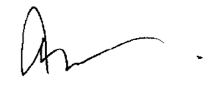
Ann Mond Johnson
Chief Executive Officer
American Telemedicine Association

